CROSSING PATROL VACANCY AT THIS SCHOOL
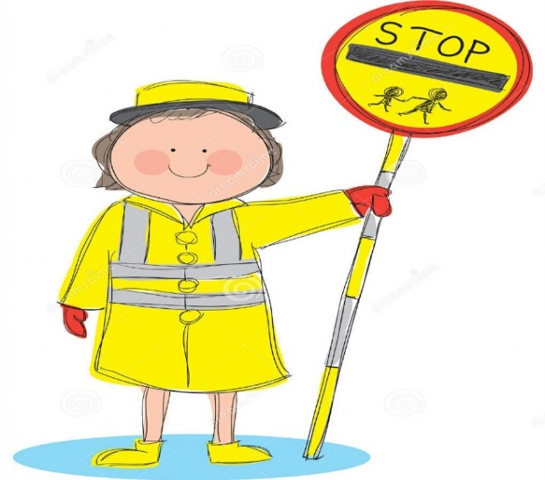

Why not join North East Lincolnshire School Crossing Patrol Service?
- Work 1 hour per day term time only
- Paid 13 weeks holiday
- Work for the local school
- Be a valuable part of the community
- Support local children on their way to school
- Receive a full uniform and paid training
- £9.30 an hour

APPLY NOW TO BECOME PART OF THE ROAD SAFETY TEAM
Email David.cullum@nelincs.gov.uk or phone Dave Cullum on 07730014061.

