Focus: A study in history: World War Two through the eyes of a child | Planning around a text:  ‘Friend or Foe’ by Michael Morpurgo | Y6 Medium Term Plan: Autumn 2019
History Objectives:  To investigate and interpret the past  -Use sources of evidence (pictorial and written) to deduce information about the past  -Seek out and analyse a range of evidence in order to justify claims about the past.  -Show an awareness of the concept of propaganda and how historians must understand the social context of evidence studied.  -Refine lines of enquiry by asking specific research questions  Build an overview of world history  -Describe the social, ethnic, cultural or religious diversity of society during WWII.  -Describe the characteristic features of the past, including ideas, beliefs, attitudes and experiences of children.  -Compare the experiences of children in different countries during WWII | 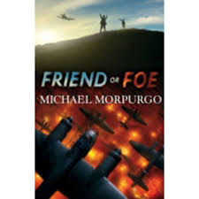 | Art Objectives:  -comment on works of art by 20th Century artists  -draw upon key ideas and styles to create original pieces, choosing appropriate colours and techniques and working with increasing precision  Music Objectives:  -perform songs from WW2 including solos, duets and in groups  -choose from a range of musical vocabulary to describe a selection of music from WW2; compare and contrast to musical choices today  -describe how lyrics have social and cultural meaning  Science Objectives (Physics):  -work scientifically, raising questions and carrying out experiments, reporting scientific findings  -understand the concept of gravity; identify the effect of drag forces such as friction, air and water resistance  -understand that force and motion can be transferred through mechanical devices such as gears, pulleys, levers and springs
To understand Chronology  • Describe the main changes during WWII (social, religious, technological and cultural).  • Understand the concepts of continuity and change over time, representing them, with evidence, on a time line.  • Use dates and terms accurately in describing events.  To communicate historically  • Use appropriate historical vocabulary to communicate, including: dates, time period, era, chronology, continuity, change, century and legacy.  • Use literacy, numeracy and computing skills in order to communicate information about the past.  • Use original ways to present information and ideas.  Themes: (opportunities for SMSC):  Differences, religious beliefs, friendship and loneliness, curiosity, understanding, power, conflict, keeping safe, using common sense. | ‘Rose Blanche’  by Roberto Innocenti and Ian McEwan  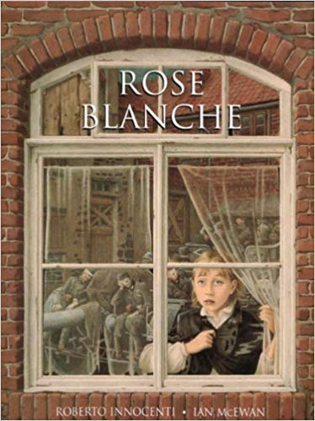 | Reading Objectives:  -identify and discuss themes across a range of writing  -draw inferences about characters’ feelings, thoughts and motives from their actions; justify with evidence  -discuss how authors use language and sentence structure, considering the impact on the reader  Anticipated Writing Outcomes:  - Exploration of writing for pleasure; write with purpose  - Writing process – Teacher modelling; plan writing (timeline); draft; proofread; edit to improve; self and peer assess; identify next steps; final drafts.  Text types:  - Historical recount  - Non-chronological report  - Diary entry  - Biography  - Letter  - Journalistic writing- news report

