Focus: A study in the history of art and artefacts | Planning around a text:  ‘The Viewer’ by Gary Crew and Sean Tan | Y6 Medium Term Plan: Autumn 2018
History Objectives:  To investigate and interpret the past  • Use sources of evidence (pictorial and artefacts) to deduce information about the past  • Select suitable sources of evidence, giving reasons for choices, depending on era  • Seek out and analyse a range of evidence in order to justify claims about the past.  • Show an awareness of the concept of propaganda and how historians must understand the social context of evidence studied.  • Understand that no single source of evidence gives the full answer to questions about the past.  To build an overview of world history  • Describe the social, ethnic, cultural or religious diversity of past society.  • Describe the characteristic features of the past, including ideas, beliefs, attitudes and experiences of men, women and children. | 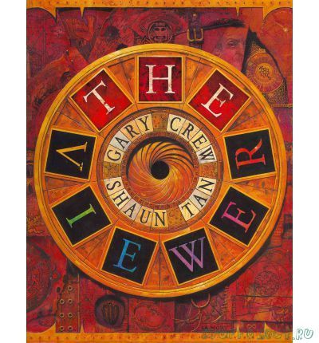  Themes: (opportunities for SMSC): Differences, friendship and loneliness, curiosity, imagination, power, conflict, keeping safe, using common sense. | Art Objectives:  To develop ideas  - Collect information, sketches and resources  and present ideas imaginatively in a sketch  book.  To master techniques  - Painting – sketch (lightly) before painting to combine line and colour; create a colour palette based upon colours observed in the natural world  - Drawing – choose a style of drawing suitable for the work (e.g. realistic or impressionistic); use lines to represent movement.  - Textiles - show precision in techniques; choose from a range of stitching techniques; combine previously learned techniques to create pieces  Sparkly Start: Visit to Lincoln’s ‘The Collection’ museum, the Usher Gallery and Lincoln Cathedral – an exploration of historical art and artefacts.  Fabulous Finish: Display our own gallery of paintings, drawings and textiles to tell stories from history
To understand Chronology  • Describe the main changes in a period of history (social, religious, technological and cultural).  • Identify periods of rapid change in history and contrast them with times of relatively little change.  • Understand the concepts of continuity and change over time, representing them, with evidence, on a time line.  • Use dates and terms accurately in describing events.  To communicate historically  • Use appropriate historical vocabulary to communicate, including: dates, time period, era, chronology, continuity, change, century and legacy.  • Use literacy, numeracy and computing skills in order to communicate information about the past.  • Use original ways to present information and ideas. | 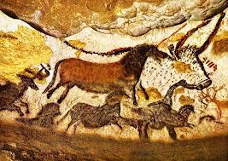  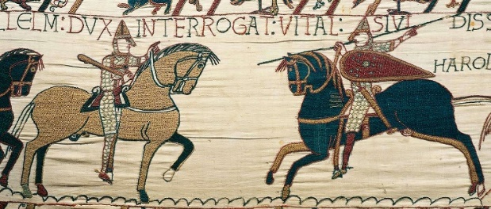  Story-telling through pictures | Anticipated Writing Outcomes:  - Exploration of writing for pleasure  - Writing process – Teacher modelling; plan writing (timeline); draft; proofread; edit to improve; self and peer assess; identify next steps; final drafts.  Text types:  - Historical recount  - Non-chronological report  - Diary entry (the ‘find’)  - Mystery story  - Journalistic writing- news report (boy missing!)

