Focus: A Study of the life and work of Leonardo Da Vinci  History – Significant Individuals | Planning Around A Text:  Leonardo and the Flying Boy by Laurance Anholt | Y2 Medium Term Plan – Autumn 2018
History Objectives:  To investigate and interpret the past  -Observe and handle evidence to ask questions and find answers about the past.  -Ask questions such as what happened? How long ago?  -Use artefacts and pictures to find out about the past  -Identify some of the different ways the past has been represented  To build an overview of world history  -Describe historical events  -Describe significant people from the past  -Recognise that there are reasons why people in the past acted as they did  To understand chronology  -Place events and artefacts in order on a timeline  -Label timelines with phrases  -Use dates were appropriate.  To communicate historically  -Use words and phrases such as: a long time ago, decades and centuries to describe the passing of time. | 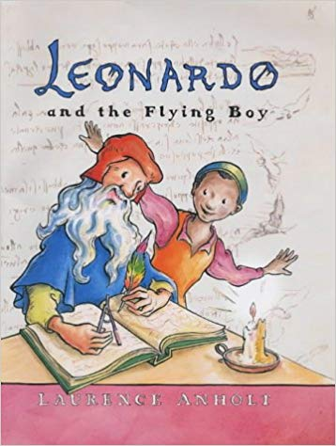  Themes (0pportunities for SMSC):  Never giving up, importance of what we have today, being creative and helping each other achieve our goals. | Art Objectives:  To develop ideas  -Explore ideas and collect visual information  -Explore different methods and materials as ideas develop  To master techniques  Drawing:  -draw lines of different sizes and thickness  -Colour (own work) neatly following the lines  -Show different tones by using coloured pencils  Painting:  -Use thick and thin brushes  Sculpture:  -Use a combination of shapes  -Use rolled up paper, straws, paper, card and clay as materials  -Use techniques such as rolling, cutting and moulding.
Sparkly Start: trip to the street life museum in Hull to see all the different types of transport we have today so we can then look at their history and focus on how some of them began such as the airplane.
Fabulous Finish: Create our own art gallery to display our portraits of the class in the Da Vinci style.
 | 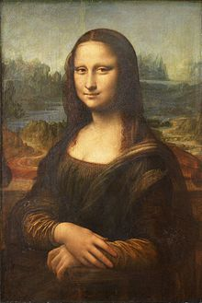  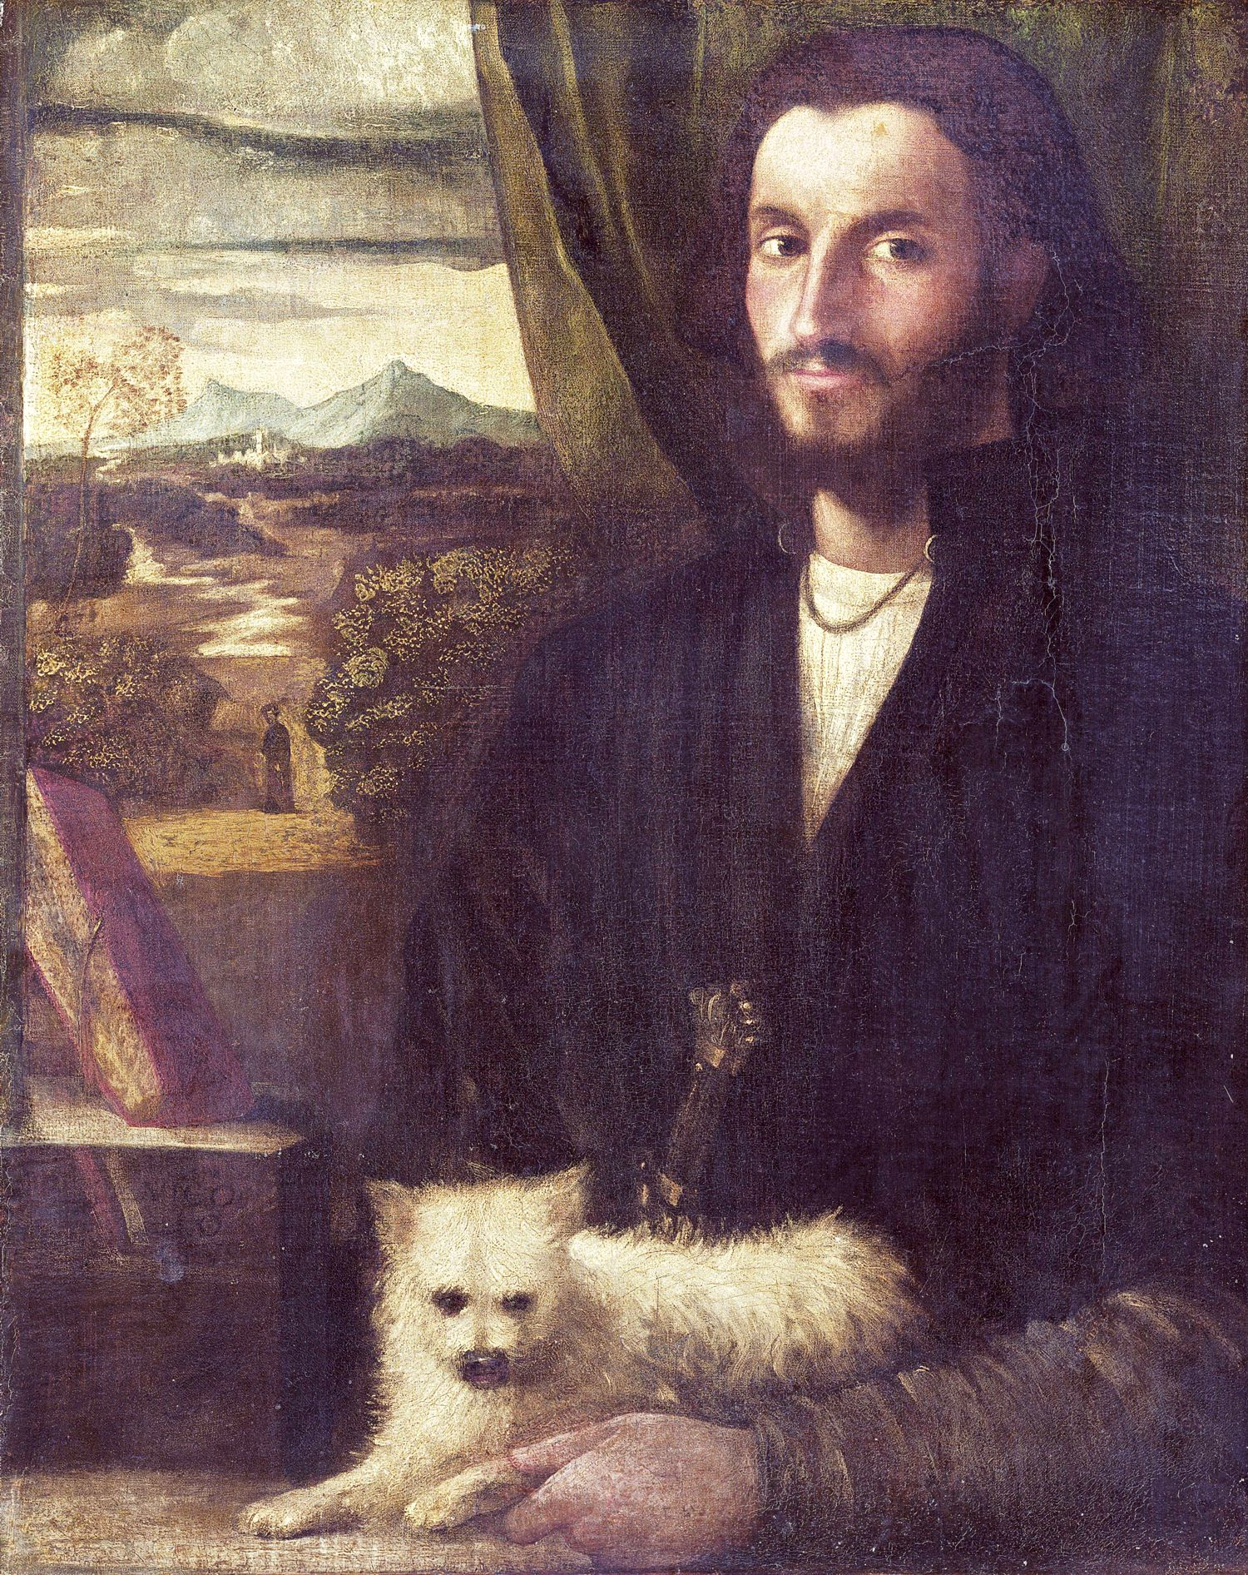  Focus on portraits and self-portraits. | Anticipated Writing Outcomes:  1.Exploration of writing for pleasure.  (Have a go at a range of text types!)  2.Writing Process (2 different text types):  Teacher modeling; plan writing (timeline); draft; proofread; edit to improve; self/peer assess; identify Next Steps in writing.  Text Types:  1.Story: Leonardo’s invention finally working.  2.Description: Leonardo’s different inventions  3.Diary: writing in person of Leonardo  4.Journalistic Writing:Newspaper report of the flying machine working.  5.Instructions: How to build the machine from the story and one that we make ourselves.

