Focus: British Tales  History – British historical figures  Geography- Continents and mountains | Planning Around A Text:  George and the Dragon by Chris Wormell | Y2 Medium Term Plan –Autumn 2019
History Objectives:  -To understand historical concepts and vocabulary.  -To know and understand significant aspects of history.  -To learn about events beyond living memory and its impact in modern national life.  -To learn about the lives of significant individuals in the past who have contributed to a national or an international achievement.  -To learn significant events and to learn dates.  Science Objectives:  -To identify and compare the suitability of a variety of everyday materials.  -To find out how the shapes of solid objects made from some materials can be changed by certain things.  -To learn what these everyday materials are used for, why and how it impacts our lives.  -To complete investigations comparing materials and practicing how to make fair tests.  Geography Objectives:  -To name and locate the world’s seven continents and five oceans.  -To name, locate and identify characteristics of the four countries and capital cities of the U.K.  -To use basic geographical vocabulary to refer to key physical features with a focus on mountain ranges. | 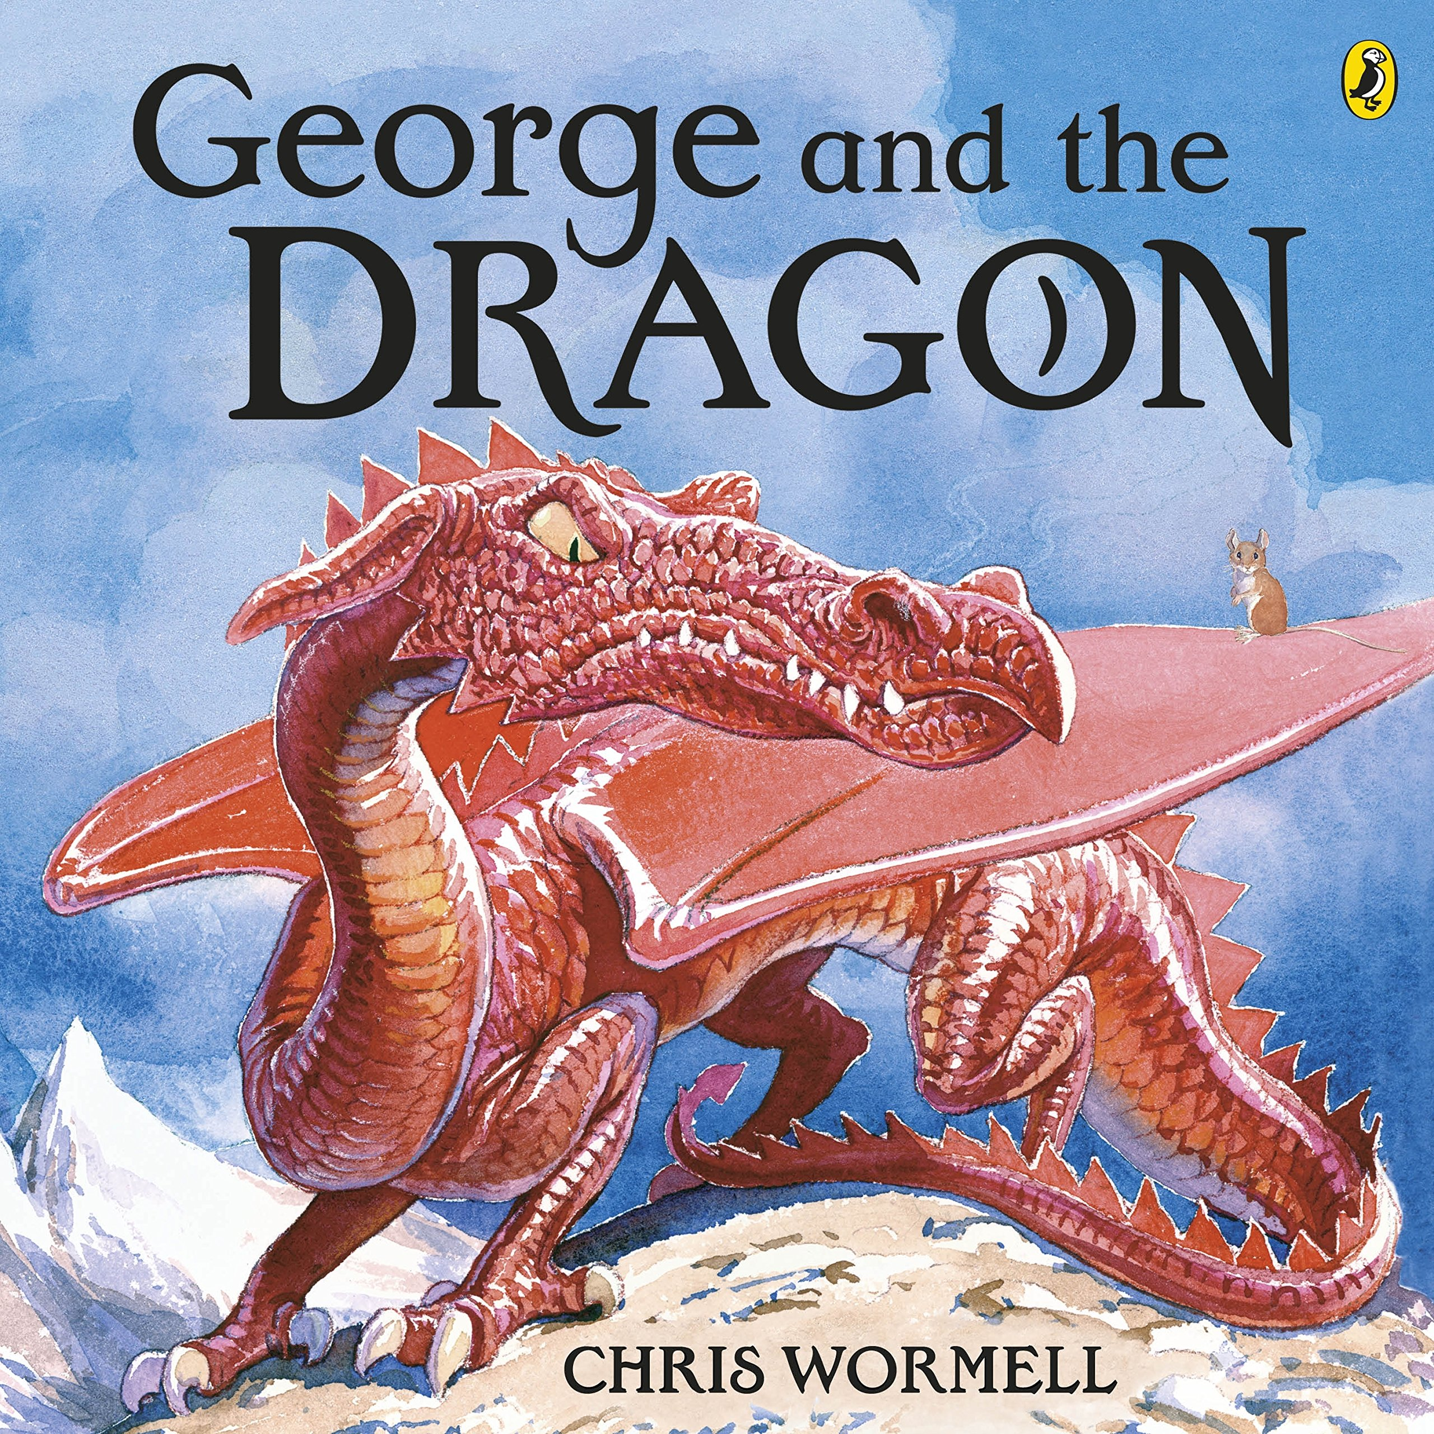  Far, far away in the high, high mountains in a deep, deep valley in a dark, dark cave, there lived a mighty dragon. He was afraid of nothing…. Until he met George! The tale of St George of England. | Art Objectives:  -To draw and sketch.  -To explore colour and develop a wide range of artistic techniques.
Design and Technology Objectives:
Design:
-To design a functional and appealing Dragon Machine.
Make:
-To select from and use a range of equipment and materials that would be suitable for the designed idea.
Evaluate:
-To evaluate the practicality of our own Dragon Machine.

 | 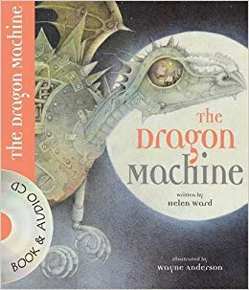  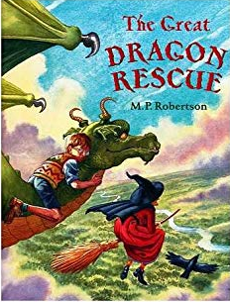  Supporting Texts: | Anticipated Writing Outcomes:  Text Types to be focused on  - Writing descriptions of characters and settings from different accounts of the same story.  - Re-telling the story from our focus book by writing it in their own words.  - Writing an alternate version of the story by changing key elements using wider knowledge of stories and characters.  - Writing a newspaper article about a key section or scene from the story.  - Writing predictions using inference about what is going to happen or what had happened.

