Focus: A study of Mayan Civilisation | Planning Around a Text: Rain Player by David Wisniewski | Y5 Medium Term Plan – Autumn 2018
History Objectives (Milestone 3)  To investigate and interpret the past  • Use sources of evidence to deduce information about the past.  • Select suitable sources of evidence, giving reasons for choices.  • Use sources of information to form testable hypotheses about the past.  • Seek out and analyse a wide range of evidence in order to justify claims about the past.  • Show an awareness of the concept of propaganda and how historians must understand the social context of evidence studied.  • Understand that no single source of evidence gives the full answer to questions about the past.  • Refine lines of enquiry as appropriate.  To build an overview of world history  • Compare some of the times studied with those of the other areas of interest around the world.  • Describe the social, ethnic, cultural or religious diversity of past society.  • Describe the characteristic features of the past, including ideas, beliefs, attitudes and experiences of men, women and children.  To understand chronology  • Describe the main changes in a period of history (using terms such as: social, religious, political, technological and cultural).  • Identify periods of rapid change in history and contrast them with times of relatively little change.  • Understand the concepts of continuity and change over time, representing them, along with evidence, on a time line.  • Use dates and terms accurately in describing events.  To Communicate historically  • Use appropriate historical vocabulary to communicate, including:  - Era  - Dates  - Time period  - chronology  - change  • Use literacy, numeracy and computing skills to an exceptional standard in order to communicate information about the past. | 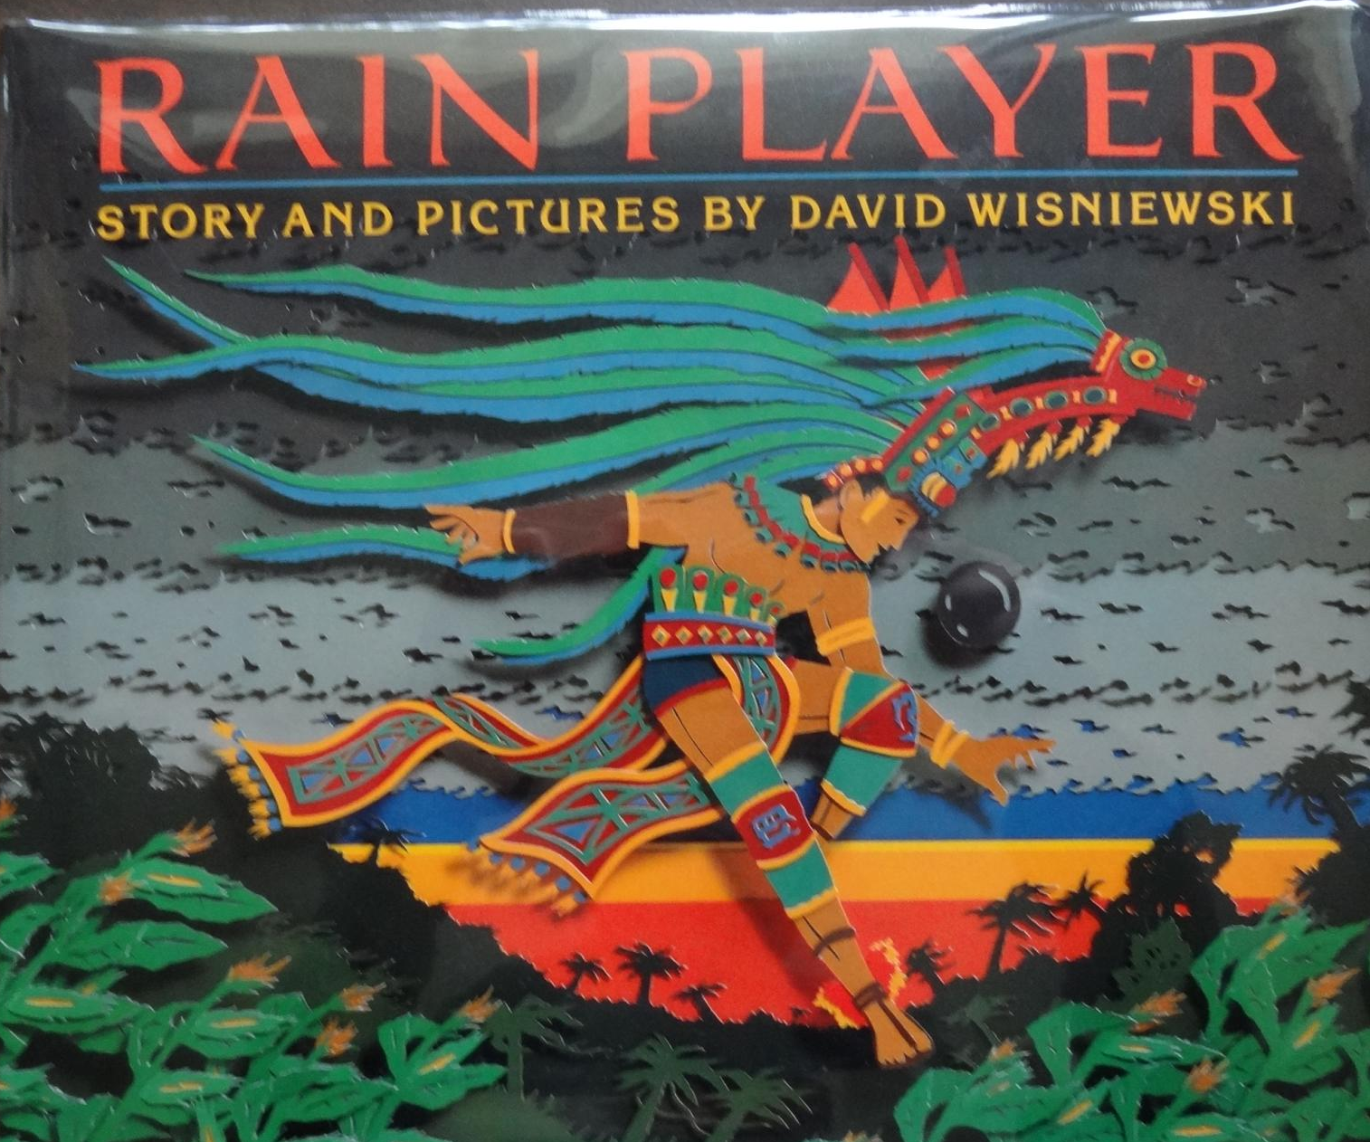  Themes (Opportunities for SMSC): Respect, friendship, loneliness, changing environments (droughts and deforestation), resilience and bravery.  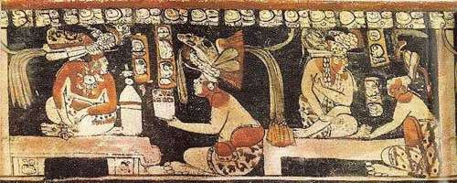  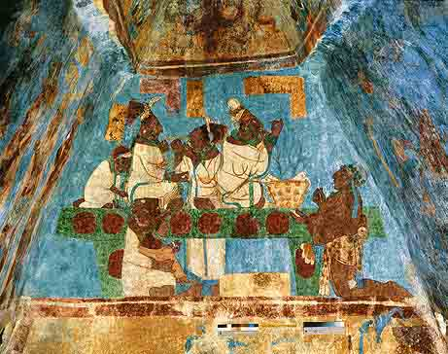  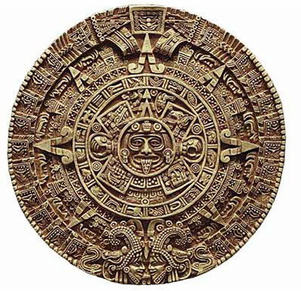  Ancient Maya art refers to the material arts of the Maya civilization, shown through paintings, carvings and sculptures. | Art Objectives:  To develop ideas  - Collect information, sketches and resources and present ideas imaginatively.  To master techniques  - Painting: sketch before painting to combine line and colour; create a colour palette based upon colours observed in the natural world  - Drawing: choose a style of drawing suitable for the work (e.g. realistic or impressionistic); use lines to represent movement.  - Sculpture: show precision in techniques; create 3D artwork looking at clay or various different materials to replicate Mayan carvings/ artefacts. Use tools to carve and add shapes, texture and pattern.  Fabulous Finish: Mysterious Mayan Showcase  - A showcase of the artwork and writing produced within the topic  Anticipated Writing Outcomes:  - Exploration of writing for pleasure  - Writing process – teacher modelling; text interrogation; plan writing (time line); draft; proofread; edit to improve; self and peer assess; identify next steps; final drafts.  Text Types  - Story – fable  - Narrative – recount  - Character study - Pik and Chac  - Diary entry – Pik’s diary entry  - Letter writing – Pik’s letter to Choc  - Persuasive writing – A plea to the gods to bring rain  - Descriptive writing – The setting amongst the drought

