Focus: The study of ourselves and others through ‘super’ heroes | Planning Around A Text:  Superworm by Julia Donaldson  Supertato by Sue Hendra | FS2 Medium Term Planning-Autumn 2019
EYFS Objectives:  C&L: To be able to listen to others and stories and use speech to link ideas  Read a variety of stories, poems and rhymes to encourage discussions  Physical:  M&H: To be able to control large and small movements.  LM: walking, running, skipping, hopping, jumping etc. SM: cutting, drawing, gluing  H&SC: To identify healthy foods and develop an awareness of activity on the body.  Maths: To be able to compare amounts and size. To be able to count 1:1  Look at the length of superworm and size of Supertato and use these to measure by comparison. How many characters do they help/save?  U the W  P&C & TW: To talk about similarities and differences in relation to self, friends, food and creatures  Talk about what we are super at and recognise we are all different. Learn about which foods are good for us to eat more of than others. Look at the features of different creatures.  T: To use computers to retrieve information  As a class find out differences in all of above | 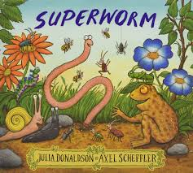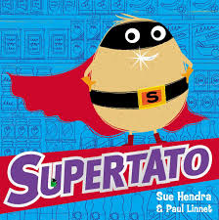  Themes: (opportunities for SMSC)  SCSA: To be able to describe self in positive terms  MF&B: To be aware of own feelings and those of others  MR: To be able to develop relationships with friends and adults in school  To talk about themselves in a positive way and know that we all have different feelings about things. To begin to show awareness of others needs and become more considerate. | Art Objectives:  To develop ideas  To collect materials for our art work, use computer programmes to make collage  To master techniques  Cutting: Practise cutting around shapes  Assembling: Practise placing shapes etc on paper to build an image
Sparkly Start: Superworm puppet meets the class

Fabulous Finish: Visit from Father Christmas

Art

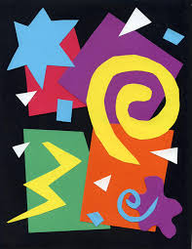

Collage inspired by Matisse
Anticipated Literacy Outcomes
1.To explore rhyme in texts rhymes
2. To explore sounds related to letter
Text Types:
1 Stories, rhyming texts
2 Counting rhymes
3 Non-Fiction texts
4 Sound books

