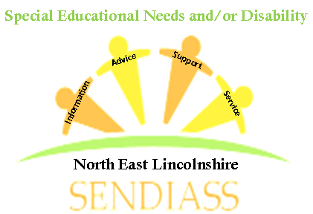
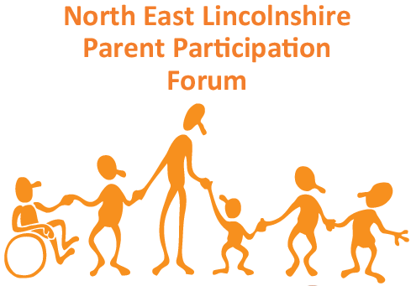

NELPPF & SENDIASS PARENT CARERS’
DROP-IN DATES FOR 2019

Pop over to Riverside Children’s Centre for a cuppa and a chat on the last Friday of every month between 10am and midday.
Meet other parent carers and benefit from free impartial advice about all things S.E.N.D. at the same time!
Friday 29 March 2019
Friday 26 April 2019
Friday 31 May 2019
Friday 28 June 2019
Friday 26th July 2019*
Friday 30th August 2019*
Friday 27th September 2019
Friday 25th October 2019*
Friday 29th November 2019
Friday 20th December 2019 (last day term)
*Children welcome on these dates in school holidays. Activities provided, plus enclosed outdoor play area (weather permitting).

Baby changing facilities and wheelchair access toilets available.

Riverside Family Hub, 74 Sorrel Rd, Grimsby, DN34 4HE

