Focus: Significant historical events, people and places in their own locality | Planning Around A Text: The Storm Whale by Benji Davies | Y1 Medium Term Plan – Autumn 2018
History Objectives:  To investigate and interpret the past  - Observe or handle evidence to ask questions and find answers to questions about the past.  - Ask questions such as: what was it like for people? What happened? How long ago?  - Use artefacts, pictures, stories, online sources and databases to find out about the past.  - Identify some of the different ways the past has been represented.  To build an overview of world history  - Describe significant people from the past.  - Recognise that there are reasons why people in the past acted as they did.  To understand chronology  - Place events and artefacts in order on a time line.  - Label time lines with words or phrases such as: past, present, older and newer.  - Use dates where appropriate.  To communicate historically  - Use words and phrases such as: long time ago, recently, years, decades and centuries to describe the passing of time. | 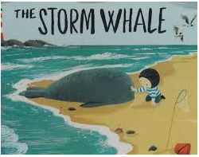  Themes (0pportunities for SMSC):  Adapting to change, new beginnings, friendship, helping others, problem solving, co-operation and working together, caring for others, family, secrets and loneliness. | Art Objectives:  To develop ideas:  - Respond to ideas and starting points.  - Explore ideas and collect visual information.  - Explore different methods and materials as ideas develop.  To master techniques:  Drawing:  - Draw lines of different sizes and thickness.  - Show pattern and texture by adding dots and lines.  - Show different tones by using colour pencils.  Painting:  - Use thick and thin brushes.  - Add white colour to make tints and black to colour to make tones.  Collage:  - Use a combination of materials that cut, torn and glued.  - Sort and arrange materials.  - Mix materials to create texture.  To take inspiration from the greats (classic and modern)  - Describe the work of notable artists.
Sparkly Start: visit to Fishing Heritage Centre.
Outcomes: sketches of nautical clothing worn by fishermen e.g. sou’wester (hat), oilskins, bibs, braces, woolen sweater. Also sketch fishing related items: trawl nets, floats etc.
Fabulous Finish: recite nautical poems in role as fishermen; nautical songs; reading aloud - fishing facts.
 | 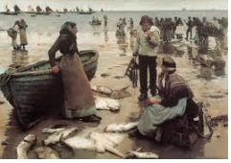A Fish Sale on a Cornish Beach, 1885 (oil painting) Stanhope Alexander Forbes (1857-1947) | Anticipated Writing Outcomes:  Exploration of writing for pleasure.  (Have a go at a range of text types!)  Writing Process (2 different text types):  Text interrogation; teacher modelling; shared writing; independent writing; edit to improve writing; re-write (further draft).  Text Types:  1. Story – retell or adaptation.  2. Thought bubbles in role as main character (freeze-framing).  3. Recount of visit to Fishing Heritage Centre.  4. Diary writing in role as main character.  5. Procedural writing – write instructions on how to care for wildlife.  6.Description of the main character.

