Focus: Changes in Britain from the Stone Age to the Iron Age | Planning Around A Text: Stone Age Boy by Satoshi Kitamura | Y3 Medium Term Plan – Autumn 2018
History Objectives:  To investigate and interpret the past  - Use evidence to ask questions and find answers to questions about the past.  - Use more than one source of evidence for historical enquiry in order to gain a more accurate understanding of history.  - Suggest causes and consequences for some of the changes in history.  To build an overview of world history  - Describe the social ethnic, cultural or religious diversity of past society.  - Describe the characteristics features of the past including ideas, beliefs, attitudes and experiences of men women and children.  To understand chronology  - Understand of change over time, representing, along with evidence, on a timeline.  - Use dates and terms to describe events.  To communicate historically  - Use appropriate historical vocabulary to communicate including: time period, era, change and chronology. | 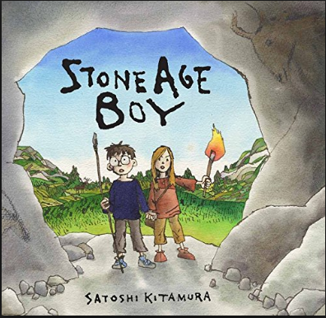  Themes (0pportunities for SMSC):  Team work, resourcefulness, sense of belonging, diversity, different cultures, participation, problem solving, understanding others, hard-.work, roles and responsibilities. | Art Objectives:  To develop ideas:  - Develop ideas from starting points in history.  - Collect information, sketches and resources.  - Adapt and refine ideas as they progress.  - Comment on artwork using visual language.  To master techniques:  Drawing:  - Annotate sketches to explain and elaborate ideas.  - Use shading to show light and shadow.  Painting:  - Use a number of brush techniques using thick and thin brushes to produce shapes textures, patterns and lines.  - Mix colours effectively.  - Use water colour paint to produce washes for backgrounds and then add detail.  To take inspiration from the greats (classic and modern)  - Create original pieces that are influenced by studies of others.
Sparkly Start: visit to Classroom in the Woods.
Outcomes: concrete experiences of life in the Stone Age. Survival techniques. Concept of bartering (first-hand experience). Diary notes, pictorial evidence.
Fabulous Finish:
Gallery of artwork. Present their understanding of what they have learned in the form of an assembly.
 | 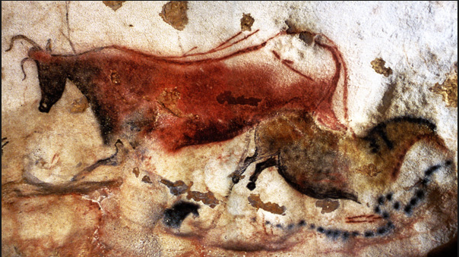  Cave Paintings in Lascaux | Anticipated Writing Outcomes:  Exploration of writing for pleasure.  (Have a go at a range of text types!)  Writing Process (2 different text types):  Text interrogation; teacher modelling; shared writing; independent writing; edit to improve writing; re-write (further draft).  Text Types:  1. Character description of cave children (compare and contrast)  2. Poetry: recite and write.  3. Description of a setting.  4. Diary writing: The day in the life of a Stone Age child.  5. Adapt the end of the story.  5. Procedural writing – write instructions on how to care for wildlife.  6.Description of the main character.

