Focus: A Study of a Theme in British History – WWII | Planning Around A Text:  The Lion and the Unicorn by Shirley Hughes | Y4 Medium Term Plan – Autumn 2018
History Objectives:  To investigate and interpret the past  1.Use evidence to ask questions and find answers to questions about the past.  2.Suggest suitable sources of evidence for historical enquiries.  3.Use more than one source of evidence for historical enquiry in order to gain a more accurate understanding of history.  4.Describe different accounts of a historical event, explaining some of the reasons why the accounts may differ.  5.Suggest causes and consequences of some of the main events and changes in history.  To build an overview of world history  1.Describe the social, ethnic, cultural or religious diversity of past society.  2. Describe the characteristic features of the past, including ideas, beliefs, attitudes and experiences of men, women and children.  To understand chronology  1. Place events, artefacts and historical figures on a time line using dates.  2. Understand the concept of change over time, representing this, along with evidence, on a time line.  3. Use dates and terms to describe events.  To communicate historically  1.Use appropriate historical vocabulary to communicate, including:  - Dates  - Time period  - Era  - Change  - Chronology  2.Use literacy, numeracy and computing skills to a good standard in order to communicate information about the past. | 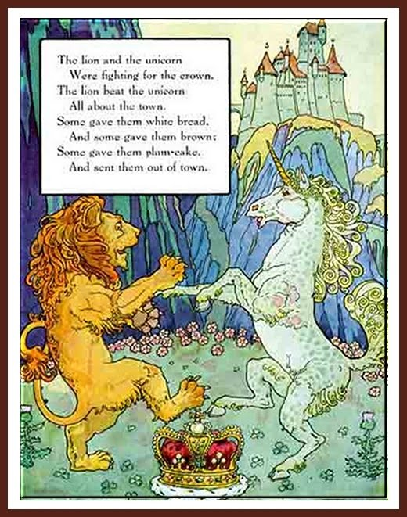Themes (0pportunities for SMSC):  War-child, propaganda, bravery, community spirit, triumph over adversity, enterprise (make do and mend, rationing, dig for Victory, evacuation), separation, loneliness and resilience. | Art Objectives:  To develop ideas  Collect information, sketches and resources.  To master techniques  Drawing: Use different hardness of pencils to show line, tone and texture; annotate sketches to explain and elaborate ideas; sketch lightly (no need to use a rubber to correct mistakes); use shading to show light and shadow; use hatching and cross hatching to show tone and texture.  Collage: Select and arrange materials for a striking effect.  Painting:  Use a number of brush techniques using thick  and thin brushes to produce shapes, textures,  patterns and lines; mix colours effectively; use watercolour paint to produce washes for backgrounds then add detail; experiment with creating mood with colour.
Sparkly Start: visit to Eden Camp
Outcomes: sketches of warplane - Spitfire; military vehicles – tank, artillery - anti-aircraft gun, and doodlebug bomb.
Fabulous Finish: recite war poems; act in role as the main character and read diary entries; letters home; war songs; gallery of WWII artwork.
 | 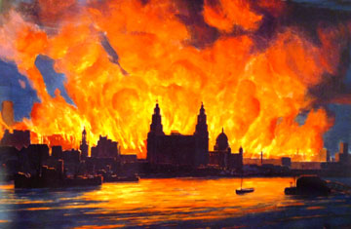Blitz Art | Anticipated Writing Outcomes:  1.Exploration of writing for pleasure.  (Have a go at a range of text types!)  2.Writing Process (2 different text types):  Teacher modeling; plan writing (timeline); draft; proofread; edit to improve; self/peer assess; identify Next Steps in writing.  Text Types:  1.Story – War-child.  2.War Poetry: recite and write.  3.Propaganda Posters: design and create.  4.Journalistic Writing – The Blitz, Evacuees.  5.Diary writing – Lenny’s journal.  6.Letter writing – Lenny’s letter home.  7.Descriptive writing – The Blitz, Lenny’s secret garden.

