Focus: The study of relationships and an awareness of history through nursery rhymes | Planning Around A Text:  Puffin Peter by Petr Horacek | FS2 Medium Term Planning-Autumn 2018
EYFS Objectives:  C&L: To be able to listen to others and stories and use speech to link ideas  Read a variety of stories, poems and rhymes to encourage discussions  Physical: To be able to use one handed tools with some control  Cutting, drawing, painting, gluing  Maths: To be able to count on and back to 10, recognising numerals and quantity. To be able to use positional language accurately.  Songs, nursery rhymes, Puffin Peter  U the W  P&C: To talk about significant people and events in their life.  Different families –relate to story  TW: To be able to talk about observations they make of birds. To sing nursery rhymes from the past and the history it relates to.  Sing nursery rhymes, draw and talk about birds  T: To use a computer to retrieve information  Watch clips about birds and looking after birds in winter | 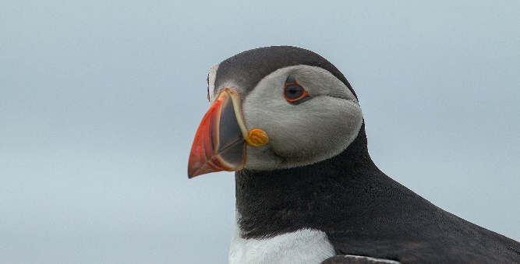  Themes: (opportunities for SMSC)  SCSA:To be able to communicate about family with others  MF&B: To be able to understand the needs of others  MR: To be able to develop relationships with friends and adults in school  To talk about and develop relationships and develop an awareness of the needs of other children and creatures. | Art Objectives:  To develop ideas  To collect ideas, sketches and resources  To master techniques  Drawing: Using different pastels to explore colour. Practise and develop solid colour strokes and rubbing to soften colour.  Painting: Using watercolours and mixing to develop colours, using strong and subtle colours.
Sparkly Start: performance of nursery rhymes
Outcomes: singing nursery rhymes, finding rhyming words,
Fabulous Finish: Bird Aviary at People Park?

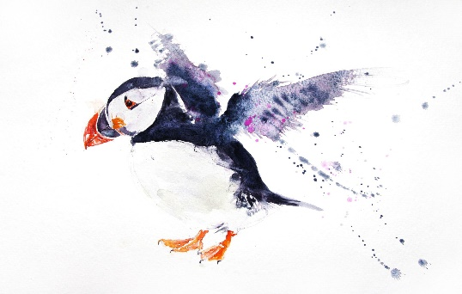

Puffin art

Anticipated Literacy Outcomes
1.To explore rhyme in nursery rhymes
2. To explore sounds related to letter
Text Types:
1 Nursery rhymes
2 Counting rhymes
3 Rhyming texts
4 Sound books

